FERPA EXPLAINED FOR
THE NITA M. LOWEY 21st CENTURY COMMUNITY LEARNING CENTERS PROGRAM
The Nita Lowey 21st Century Community Learning Centers is a federal TITLE program (TITLE IV B) and districts or community groups apply for grant funding to operate an afterschool and/or summer program for at-risk children. As a federal program, we must follow all federal statutes and guidelines, which include The Federal Educational Rights and Privacy Act, the protects the privacy of student records.
What is the Family Educational Rights and Privacy Act (FERPA)?
The Family Educational Rights and Privacy Act (FERPA), 20 U.S.C. §1232g, is a Federal privacy law administered by the Family Policy Compliance Office (FPCO or Office) in the U.S. Department of Education. FERPA and its implementing regulations in 34 CFR part 99 protect the privacy of students’ education records.
Source- https://www2.ed.gov/policy/gen/guid/fpco/pdf/reasonablemtd_agreement.pdf
To Comply with FERPA and other Federal Requirements, the Superintendent and building Principal MUST sign an assurance written agreement that includes providing the data we need to report for this federal program (21st Century Community Learning Centers -TITLE IV B).
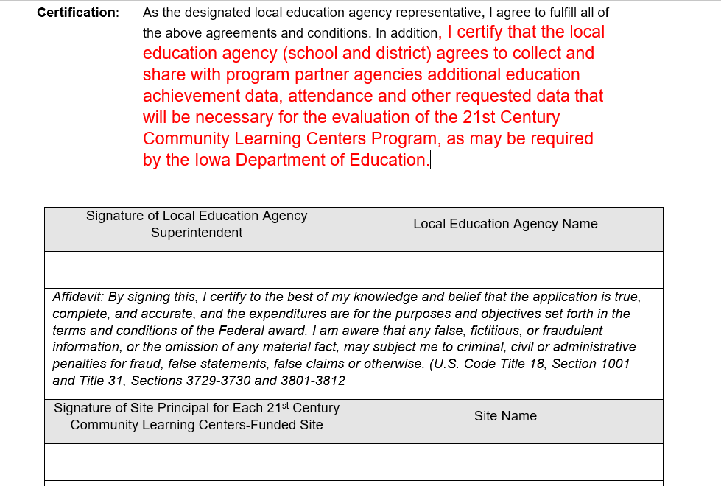
TIP- When you start getting signed assurances in the application -it makes data sharing easier down the road.

Our federal Title program by agreement (above) and provision in FERPA statute and other federal statutes has legitimate access to student identifiable academic data for federal reporting, audits and evaluation.
FERPA 99.35 provides the following:
(B) That the purpose for which the personally identifiable information from education records is disclosed to the authorized representative is to carry out an audit or evaluation of Federal- or State-supported education programs, or to enforce or to comply with Federal legal requirements that relate to those programs;
Source: https://studentprivacy.ed.gov/node/548/
Because we are diligent with protecting student privacy, we ask that the district data person or principal be the person who actually sees the student identifiable data. For our reporting, we only need aggregated program data for both federal reporting and evaluation.
WE NEED ONLY AGGREGATED DATA FOR OUR REPORTS- WE DO NOT REQUIRE ANY STUDENT IDENTIFIABLE RESULTS.
We establish that we understand and comply with FERPA, and that we do not require any student identifiable data, but we do require data and the grant requires it and the Superintendent and Principals have signed assurances to comply with the grant.

Starting in 2022, the data we report to the US Dept. of Education for this program will change. We must begin collecting this data in the summer of 2021 and the Fall of 2021 because we report about the previous school year, not the current school year.
Below is the data of the new data we have to collect for our program.
The program can supply the district with a list of student names who are participants and we will need the following data:
GPRA Measure 1- Percentage of Students in grades 4-8 participating in the 21stt CCLC program (school year and or summer) who demonstrated growth in Reading and English (Language Arts) on state assessments.
This data should be readily available in any student information system (SIS) and the district data person will have to generate a report. Hopefully, they can save this report and reuse it year after year for data reporting for the grant. Note: We need Improvement- not proficiency.

GPRA Measure 2-Percentage of students in grades 7-8 and 10-12 who attended the 21st CCLC program (school year and or summer) with a prior year unweighted GPA of less than 3.0 (grade of B) who demonstrated an improved GPA.
GPRA Measure 2 ONLY APPLIES to secondary programs. Elementary programs do not need to report on this measure. QUICK CONVERSION- Letter Grade of A=4 , B=3, C=2, D=1 You will need to do an average of all the letter grades to calculate the Grade Point Average (GPA).
Want to know more?
https://www.albert.io/blog/how-do-you-calculate-your-unweighted-gpa/

GPRA Measure 3- Percentage of students in grades 1-12 who attended the 21st CCLC program (school year only) who had a school day attendance rate of at or below 90% in the prior school year and who demonstrated an improved attendance rate in the current school year.
GPRA Measure 3- We are looking at attendance improvement for ALL students. Did the students below 90% improve their attendance this year?

GPRA Measure 4- Percentage of students in grades 1-12 who attended the 21st CCLC program (school year and or summer) and who experienced a decrease in in-school suspensions compared to the previous year.
GPRA Measure 4- This information is available in the Student Information System (SIS) It may be restricted to the Principal and the district data person. Remember we only need aggregate data that will be reported as a percentage.

GPRA Measure 5- Percentage of students in grades 1-5 who participated in the 21st CCLC program (school year and or summer) who demonstrated an improvement in teacher (or program staff) reported engagement in learning. This measure can be addressed via a teacher(staff) survey.
GPRA Measure 5 is the only one that will be a SURVEY to gain anecdotal data about student engagement based on observations. Programs can generally do this on their own or a local evaluator can be contracted for this measure.

The Government Performance and Results Act (GPRA) of 1993 requires federal agencies to prepare a strategic plan covering a multiyear period and requires each agency to submit an annual performance plan and an annual performance report.
The US Dept. of Education has an online data collection site (APR- Annual Performance Report) where all 50 states report this program data annually and the national aggregated data is provided every year to Congress.
Therefore, it is critical that we have the cooperation of all stakeholders to provide the required data for this federal TITLE program each year.
Additionally, other federal statutes require recipients of federal funds to provide the required information when requested.
Edgar 200.336 (a) The Federal awarding agency, Inspectors General, the Comptroller General of the United States, and the pass-through entity (SEA), or any of their authorized representatives, must have the right of access to any documents, papers, or other records of the non-Federal entity which are pertinent to the Federal award, in order to make audits, examinations, excerpts, and transcripts. The right also includes timely and reasonable access to the non-Federal entity's personnel for the purpose of interview and discussion related to such documents
NOTE: You should provide contact information for grantee support here. If you use this, please remove my name and add your local state contact information below.

You are free to copy the contents of this document but please credit the Iowa Dept. of Education

If you have any questions about the data requirements for the 21st CCLC program, please contact Vic Jaras, Consultant, Iowa Dept. of Education. Vic.jaras@iowa.gov

